What the time tRavelleRs FoUNd lessoN: layeRs, Fossils & RoCKs
lessoN PlaN

Key Stage 2
NatioNal CURRiCUlUm: | Science  Recognise that fossils provide information about living things that inhabited the Earth millions of years ago. | D&T  Use research and develop design criteria to inform the design of innovative, functional, appealing products that are fit for purpose. | Geography  To be able to describe and explain geographical processes.
teaChiNg objeCtives: | To become familiar with the idea that the earth beneath our feet is formed in layers into which various fossils have become trapped. | To make models demonstrating learning out of different resources.
ResoURCes: | BIC® Kids Plastidecor® colouring crayons, BIC® Kids Aquacouleur™ colouring pencils, BIC® Kids Visa™ colouring felt pens, BIC® Kids Ecolutions® Evolution™ colouring pencils, brush pen, tissue paper, cartridge paper, cards, a variety of different wallpaper surfaces, sugar paper, corrugated card, glue gun and PVA glue.  Research some clips on how fossils are formed plus review the Oxford University Museum’s fossil information and the Natural History Museum’s website for illustration purposes.
Whole Class:
3-5mins:
Recap with the children how fossils are formed by showing them the Natural History Museum website

15 mins:
Show the materials that are going to be used for the layers. Explain why each choice relates to the layer being made, and the reasons for making it appropriate.

Show how to fix the layers together, ruching and folding for example. Show how to add texture by scrunching, ripping, tearing and pleating. Make links to how this would have happened as the earth layers formed.

Show how we can create different pattern structures onto the textured surfaces to show differentiation of land layers.

Tell children what their finished product needs to show (i.e.) distinct layers of texture and colour, showing geological processes and the forming of land over thousands of years.

Indicate where to access resources that they’ve seen demonstrated, and start the activities.
easy/mediUm/haRd:
All working at same task: Children to set up an area to work in and layer up their cross section using the different techniques demonstrated.

Children briefly discuss what their group/partnership wants the model to look like, and which geographical processes they want to show in their finished piece.
PleNaRy: | Ask the groups to select and talk about one geographical process that is demonstrated by their model, they can share any difficulties they  overcame, or compromises they felt their materials forced them to make. (This shows the level of understanding of the D.T. aspects of their work).
oUtComes: | Children will  - Discuss, with understanding, terms that describe Geographical processes previously studied.  - Talk with familiarity about techniques they have made use of.  - Make a model that shows a cross section of the earth layers and gives reference to various geographical processes.

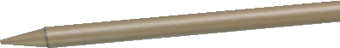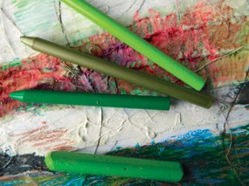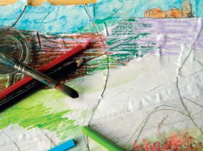
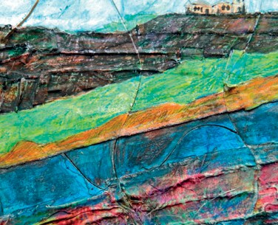Discover Teachers’ Corner at:
www.bickids.co.uk

