What the time tRavelleRs FoUNd lessoN: diNosaUR diy
lessoN PlaN

Key Stage 1

NatioNal CURRiCUlUm:

Science
Recognise that living things have changed over time and that fossils provide information about living things that inhabited the Earth millions of years ago.

Identify how animals and plants are adapted to suit their environment in different ways and how that adaptation may lead to evolution.

D&T
Use research and develop design criteria to inform the design of innovative, functional, appealing products that are fit for purpose.

teaChiNg objeCtives:
To create a skin surface of a dinosaur, drawing on design plans, collected images and texture samples, and knowledge of dinosaurs from the chosen period of the Mesozoic era.
To choose from a selection of materials to create and then cover dinosaur shape.

ResoURCes: BIC® Kids Plastidecor® colouring crayons, BIC® Kids Aquacouleur™ colouring pencils, brush pens, pre-textured board (prepped in a previous session).
Check out the Natural History Museum’s directory of dinosaurs, showing body shapes;
debate about dino-fuzz and more.

Whole Class:
Recap on previous studies and gallery of samples about dinosaur skins and surfaces, including looking at modern animals for inspiration. Watch any starter clips chosen to inspire.

Explain to the children that they are going to cover their dinosaur(s) in this session, using their designs or notes on skin surfaces. Allow them some time to share their designs with a partner. Ask them to consider What patterns could our dinosaur have had on its skin surface?

Next, show the children the resources provided and demonstrate the selection of a pattern and use of the resources to create each paper section. Show them the outline that the class chose to “cover with skin” in the previous session.

easy/mediUm/haRd:
Using BIC® Kids Aquacouleur™ colouring pencils:
- Layer different colours to produce a greater depth of colour and a range of tones
- Block in colour by working with pencil strokes that are all applied in the same direction
- Control depth of colour by applying different pressures on the pencil tip.

BIC® Kids Plastidecor® colouring crayons:
- Experiment with pressure to achieve bold and light lines
- Use a wash of BIC® Kids Aquacouleur™ over the plastic crayon drawing
- Prepare a drawing surface by colouring in solid areas with the plastic crayon, applying a top coat of green and blue over the top and suggesting hair/ feathers by scraping into that surface with a sharp tool. (H & S)

PleNaRy: When the children have finished working on their sections, their d to complete for display. Ask everyone to display their sections la overlapping) on the table, (alongside their samples and collected from the previous sessions).
Ask the class to move around the table displays, offering positive
Then sit everyone together and, as a class, blutack the sections onto the display dinosaur outline.

oUtComes: Children will
  - Create a skin surface of a dinosaur, drawing on design plans, and knowledge of dinosaurs from the chosen
period of the Mesozoic era
  - Discuss their dinosaur’s appearance and how its skin is adapted to its environment.
  - Choose from a selection of materials to create and cover a dinosaur outline.

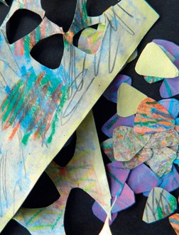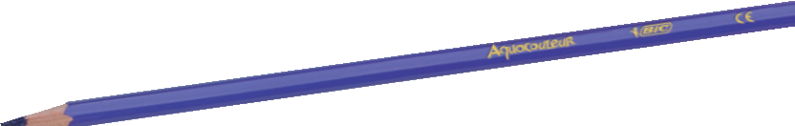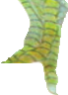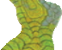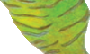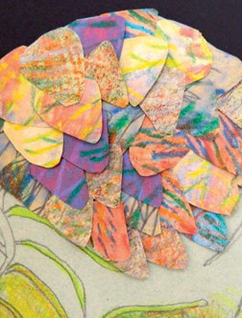

inosaurs should be ready id out together (possibly notes on the patterns

comments on the design-to-making process.
Discover Teachers’ Corner at:
www.bickids.co.uk

