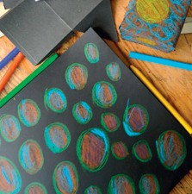What the time travellers saW lessoN: the time maChiNe
lessoN PlaN

Key Stage 2
NatioNal CurriCulum: | D&T: Use research and develop design criteria to inform the design of innovative, functional, appealing products that are fit for purpose.
teaChiNg objeCtives: | To create the Time Machine model to be used in the I.C.T. short animation of the Time Travellers’ “documentary”.
resourCes: | BIC® Kids Plastidecor® colouring crayons, polystyrene ball, small wooden sticks (skewers), masking tape, paper clips, string, black sugar paper
Whole Class:
Before the lesson, prepare the workspace by placing all resources in the centre of tables. Ensure you have enough polystyrene balls for at least one between (number expected in each group) children. Watch any starter clips you have chosen to inspire.

Explain that the objective is to make a time machine for a short animation showing how the time travellers arrived and what they found.

Discuss how the patterning for the surfaces was chosen to allow the time machine to hover and observe the dinosaurs without being detected and will therefore have a similar surface texture, pattern and colour.

Demonstrate how to make each piece, how to pattern its surface, and how it will be put together once the pieces are complete.
easy/medium/hard:
Groups must make and decorate the time machine, covering the surface of the black sugar paper pieces for each component of the time machine puzzle. Premade nets of cubes and pyramids can also be decorated.

Twist the pieces into cones, fix the small wooden sticks (skewers) in place, and then attach the pieces to the main time machine. The cubes and pyramids, when assembled, will be secured to the top and bottom.
PleNary: | Bring parts of the product together and show the finished model/s hung in front of the backdrop. Explain that should the filmmaker plan a disintegration of the time machine, or a bringing together of the pieces for their film, it is now possible with this model.
outComes: | Children will have made a time machine model ready for  a) display and b) inspiring the film making class.  The time machine is made up of about 50 decorated pieces of black sugar paper, about A5 size. These are then twisted into cones, a wooden skewer is fixed inside and then put into a small polystyrene ball. This is then suspended in front of a space backdrop.  Mark making is used to pattern the black sugar paper, some that are on show and available to copy and others from imagination.

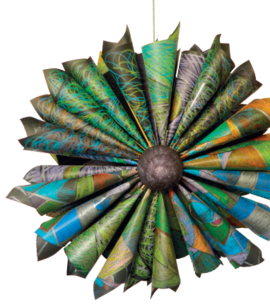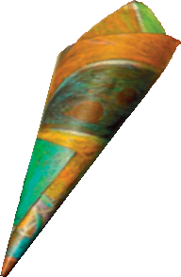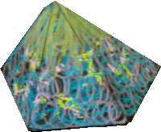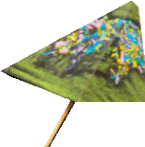
Discover Teachers’ Corner at:
www.bickids.co.uk

